Pre-K Supply List 2023-2024
Please label the * items below with your child’s name.
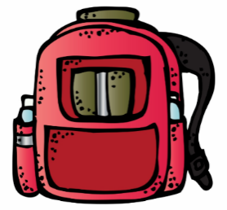
1-Large backpack*
1-Small blanket for rest time*
1-Complete change of clothes to keep at school
in gallon size Ziploc bag (tops, bottoms, underwear, socks) *
1-Rain boots*
1-Set of snow gear (by November)-snow boots, pants, coat, hat, gloves*
1-One subject spiral notebook (any color) *
1-Plastic standard workbox (approx. 8x5x2)-no zippers please *
1-Scissors-Fiskars blunt edge (no plastic blades) *
8-Playdoh containers
2-Watercolor Paint Set (8 colors)
1-Boxes of Crayola crayons (16 or 24 count)
1-Pkg Thick Crayola Washable Markers
2-Elmer’s Liquid Glue
1-Family photo (electronic is perfect)
10-Glue sticks
Optional Donations for classroom use:
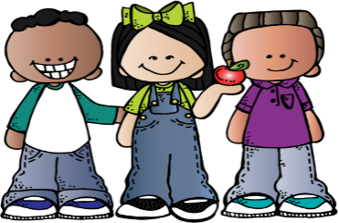
Tissue boxes, Playdoh, Craft sticks (large & small), craft sticks, google eyes, stickers, paper towel tubes, pom poms, “fun” pens/markers, ribbon, scrap fabric, paper bags, Fiskars scissors,

